Colorado CPA Compliance for Log360
Strengthen data protection and meet Colorado CPA compliance with Log360.
Region: USA | Type: Data Privacy | Category: Compliance | Pricing: Free

Overview
The Colorado CPA compliance extension in Log360 helps organizations meet the Colorado Privacy Act (CPA), Colorado's comprehensive consumer privacy law granting residents rights over personal data and imposing security and breach notification duties on controllers by providing centralized log management, real-time breach detection, and access audit reporting. The platform supports Colorado CPA requirements for security safeguards, breach notification, consumer rights evidence, sensitive data access controls, processor oversight, data protection assessments, data flow monitoring, and audit records.
For Security Safeguards — Duty of Care, Log360 provides authentication monitoring, network security reports, threat detection, and privileged access tracking as primary SIEM-level technical controls evidencing Duty of Care compliance. To address Breach Detection and Notification, the platform's real-time threat alerts, anomaly detection, and incident timeline reconstruction minimize detection time and provide breach evidence for 30-day notification obligations. The extension also supports Consumer Rights Evidence and Access Audit by providing capabilities that provides user activity logs, file access audit reports, and account management records to substantiate timely fulfilment of consumer data rights requests.

Key Features
- Sensitive Personal Data Protection: Log360 monitors privileged access to sensitive repositories, failed file access attempts, and USB events to detect unauthorized access to sensitive personal data.
- Third-Party Processor Monitoring: Log360 monitors cloud storage integration events, AWS IAM activity, and third-party access logs to track processor data handling and detect unauthorized processing.
- Data Protection Assessment Evidence: Log360 provides vulnerability scan results, access anomaly reports, privilege escalation alerts, and network security events as risk indicators for DPA quantification.
- Data Flow and System Activity Monitoring: Log360 monitors database activity, cloud storage file operations, network traffic, and AD directory changes to audit actual data flows against disclosed purposes and detect undisclosed processing.
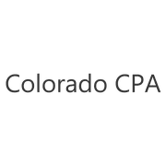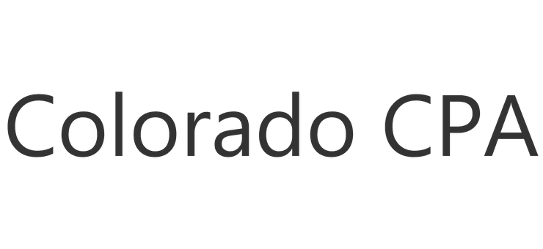

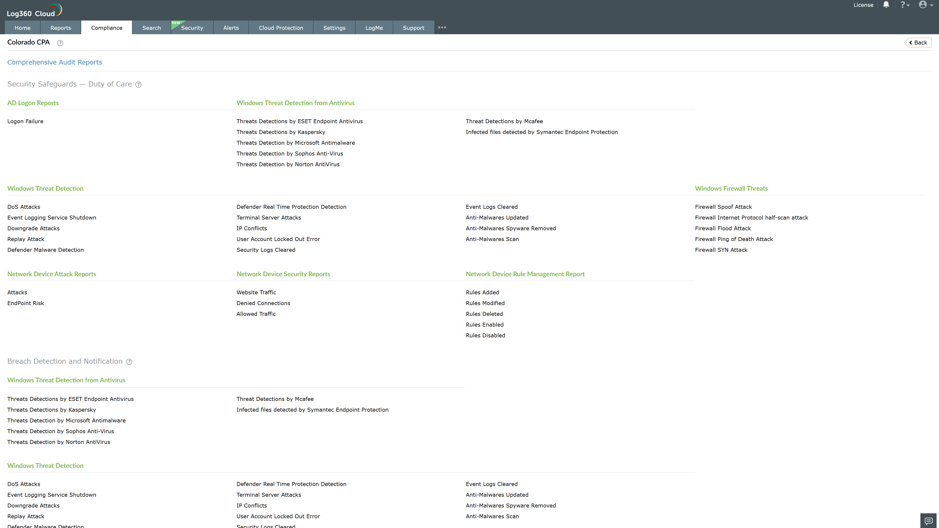
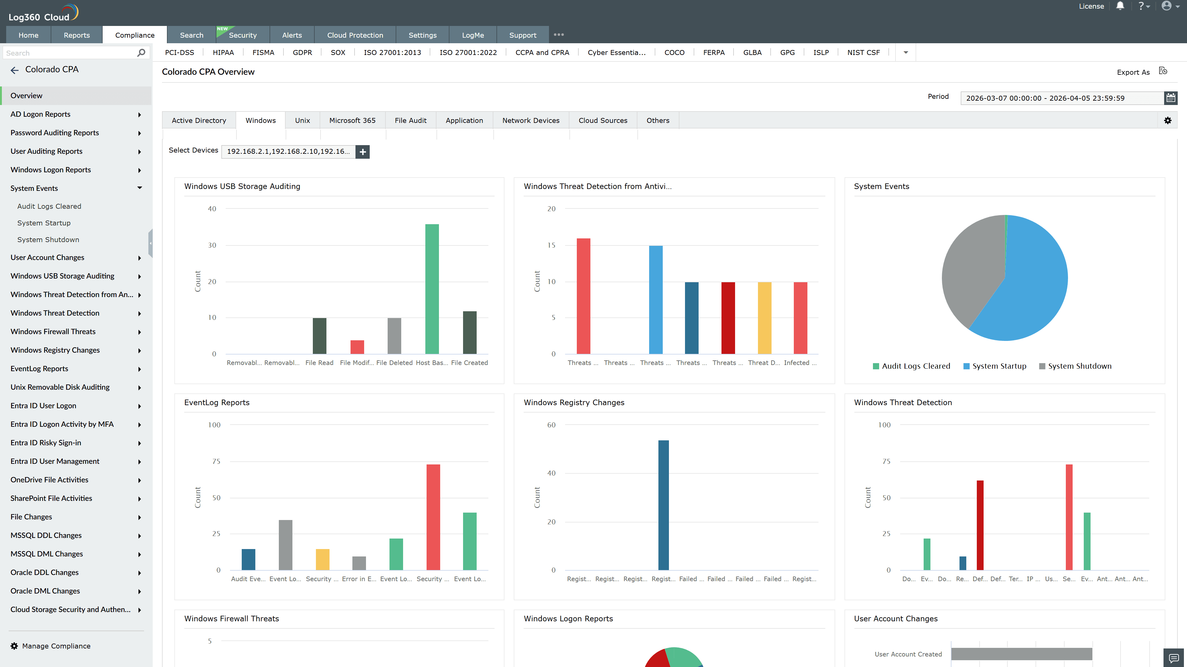
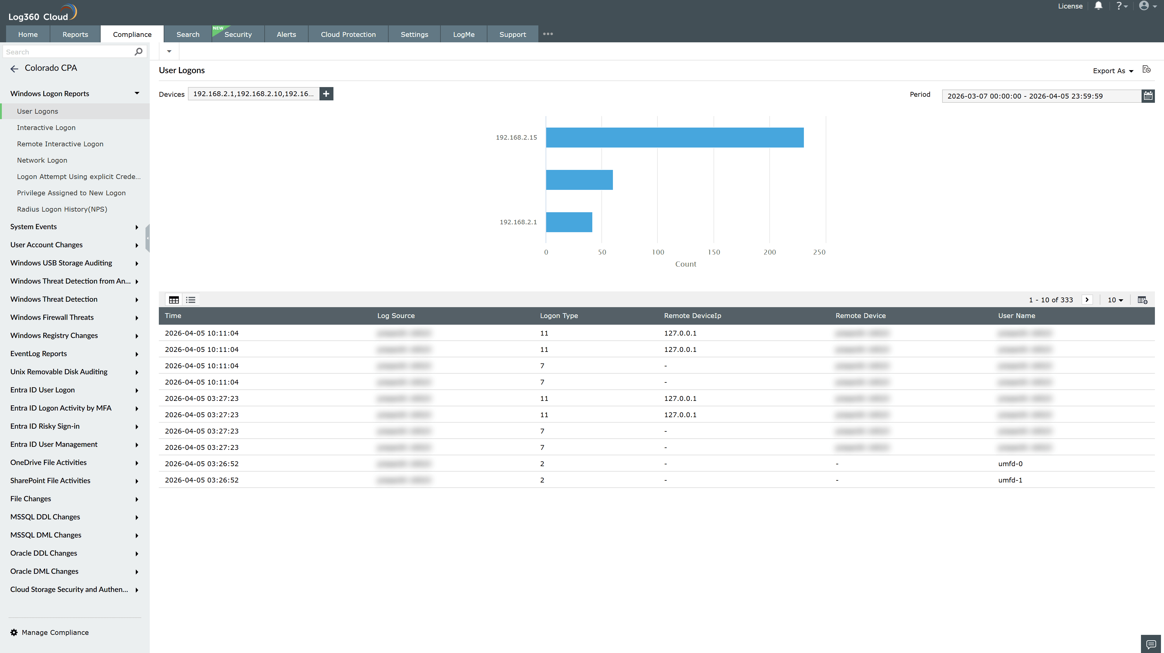
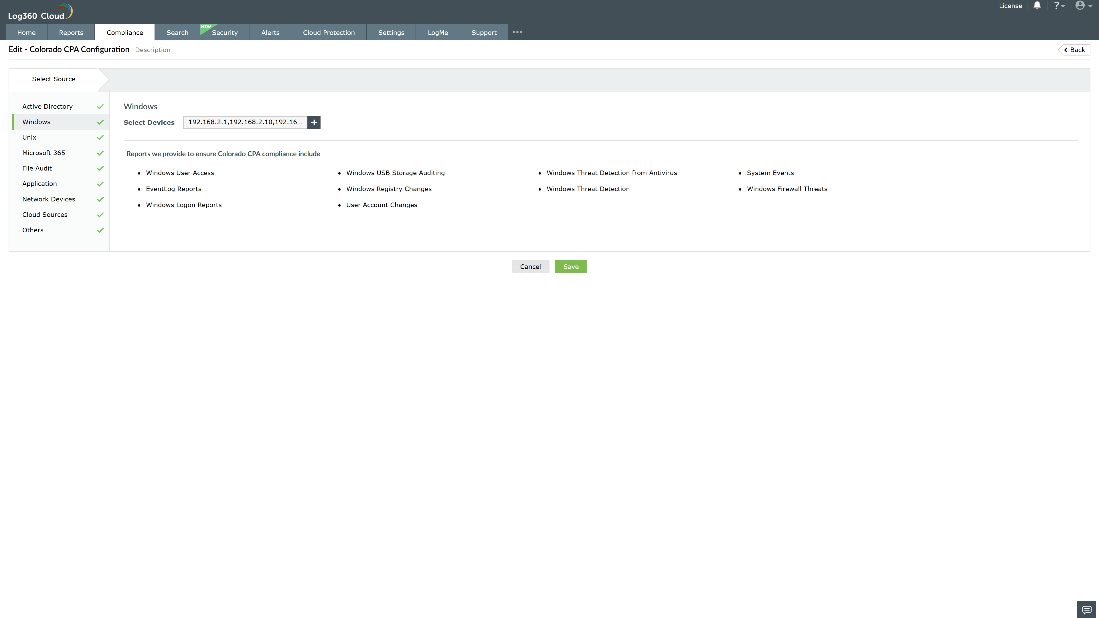
Valid Submission : Yes
Supported Editions : Free, Basic, Standard, Professional, MSSP
Help Document : https://www.manageengine.com/log-management/help/integrations/compliance-extensions.html
Help Video : Not provided
Tags : Log360, Compliance, Privacy monitoring, Data privacy, Regulatory compliance
Supported DCs : US, IN, JP, CA, AU, UK and EU
Privacy Policy:
Terms of Service:
Release Notes:
Predefined reports for the Colorado CPA.

